BiDiMate Pre-Qualification Form
Information Date : May 10, 2022 | Site : Edge building,

PIC. PT. Cloudtronics Indonesia | Vendor PIC. ____________
Name : Faiq Fawwaz A  Position: Support | Name :  Position:

OTDR Test Report:

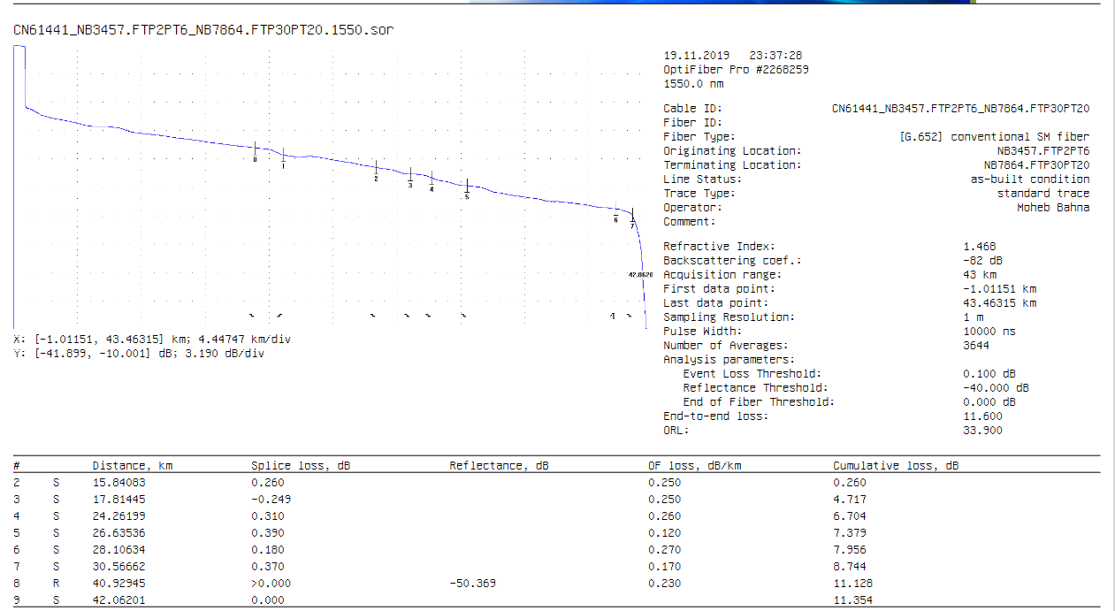

DDM or Power Meter / LS Information
dBm
dBm
Fiber 1 Information
Km
IL 1310 nm
IL 1550 nm

SFP

Fiber 1
Tx
RX
Rx
TX
dBm

Fiber 2
dBm

SFP

Fiber 2 Information
Km
IL 1310 nm
IL 1550 nm

Circle choice :
Cable Type : SMF / MMF ( OM5 / OM4 / OM3 / OM2 / OM1 )

Patch Lead Type : SMF / MMF ( OM5 / OM4 / OM3 / OM2 / OM1 )

Link Length :

Connector Type : SC / ST / LC / FC

Polish Type : APC / UPC / Other

Patch Color : Green / Blue / Other

Coupling Type : SMF / MMF

Supporting Document :

This report is made with a sense of responsibility and signed by the PIC.
Jakarta, May 12, 2022

PIC. PT. Cloudtronics Indonesia | PIC. ________________
………………………………….. | ……………………………………….

