TROUBLESHOOTING FORM
Date Investigation : May 10, 2022 | Site : Edge building,

PIC. PT. Cloudtronics Indonesia | Vendor PIC. ____________
Name : Faiq Fawwaz A  Position: Support | Name :  Position:

Device used :
Switch : Dell
Part Number : SFP+10G-13-LR-Q
Serial Number : CLD2112050322, CLD2112050323, CLD2112050324, CLD2112050325
Patchlead Type : SMF
Length : 10 Km
Switch Version :
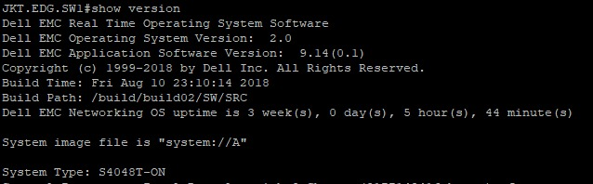

Detail Information
dBm
dBm
Fiber 1 Information
Km
IL 1310 nm
IL 1550 nm

SFP

Fiber 1
Tx
RX
Rx
TX
dBm

Fiber 2
dBm

SFP

Fiber 2 Information
Km
IL 1310 nm
IL 1550 nm

Circle choice :
Cable Type : SMF / MMF ( OM5 / OM4 / OM3 / OM2 / OM1 )

Patch Lead Type : SMF / MMF ( OM5 / OM4 / OM3 / OM2 / OM1 )

Link Length :

Connector Type : SC / ST / LC / FC

Polish Type : APC / UPC / Other

Patch Color : Green / Blue / Other

Coupling Type : SMF / MMF

Investigation :
Tx and Rx read as shown below: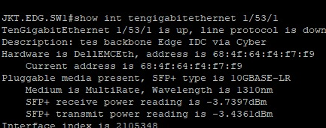
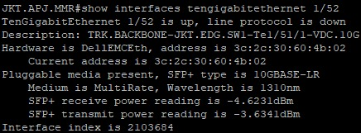

Investigation Finding :
- SFP is read but the link is not up
- SFP testing before the Eid holiday (28 April 2022) shows the link still can't be up
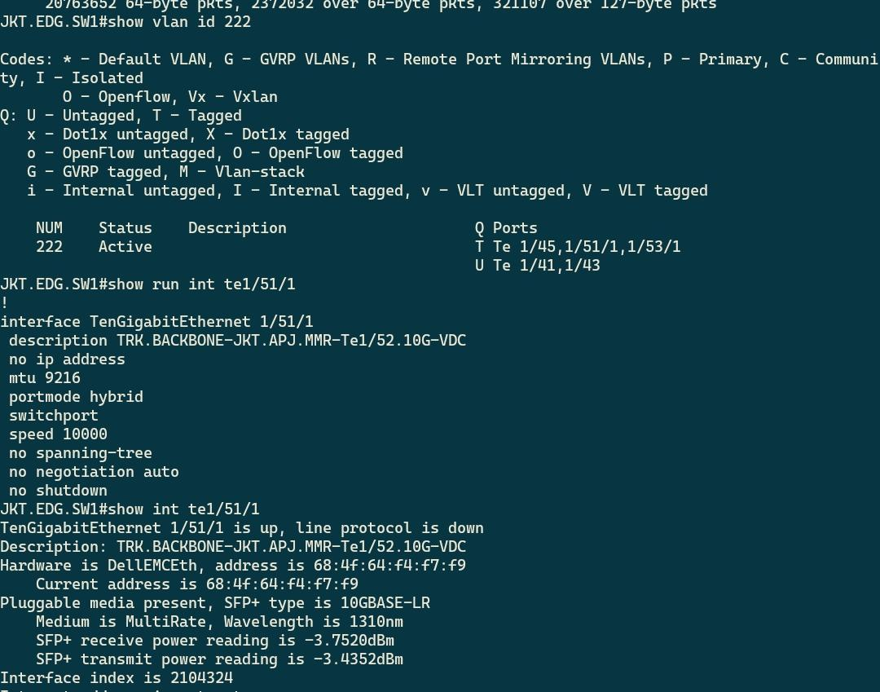

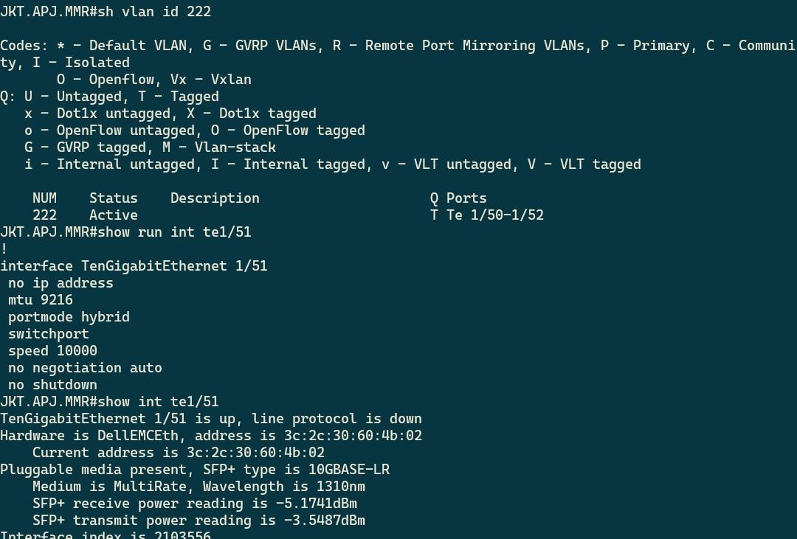

Troubleshoot :
- Re-check the Cloudtronics brand SFP+ 10G LR software.
- SFP software/code is appropriate and not reprogrammed.
- Check the supporting equipment, try to change the pachlead from MMF to SMF.
- Inspection of SFP cores, and SFP cores are found to be in clean condition.
- Try running SFP with another dell switch with the same switch type.
- The client team set the Dell switch and SFP+ 10G LR to work properly on these two Dell devices.
- Tried again with the main switch, by trying on a different port.
- SFP is running well.

Result :
- SFP is not recoded.
- SFP is working properly
- Change the SFP port on a different Dell Switch with the same type.

Status has changed to up.
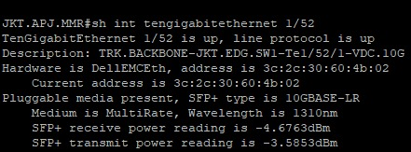
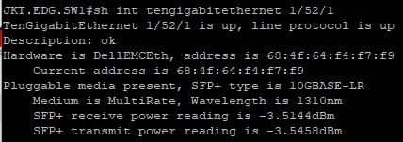

Supporting Document :

This report is made with a sense of responsibility and signed by the PIC.
Jakarta, May 12, 2022

PIC. PT. Cloudtronics Indonesia | PIC. ________________
………………………………….. | ……………………………………….

